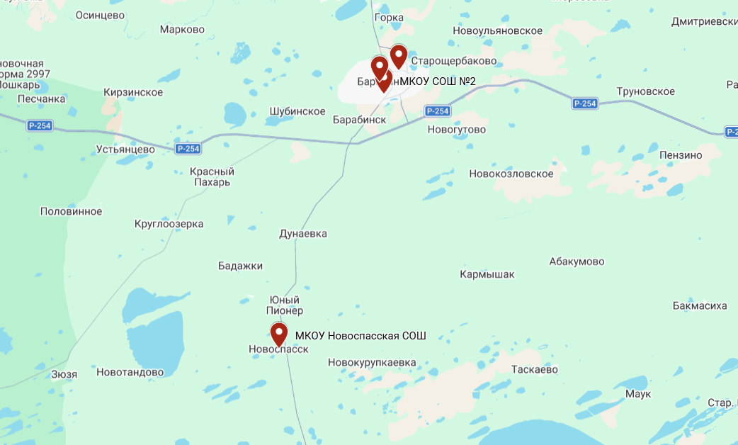
https://www.google.com/maps/d/edit?mid=1VpDSufqqNDlNDl8y0VIJ7wxjYU3-18I&usp=sharing

